The University of Azad Jammu and Kashmir Muzaffarabad

Student Name: Qurat Ul Ain Fatima
Roll No: 2024-SE-05
Course Title: Database Systems
Course Code: CS-2204
Lab Instructor: Awais Rathore
Department: Software Engineering

1. Introduction:
In this project, I designed and implemented an e-commerce database using MySQL in XAMPP. The main purpose of this database is to manage users, roles, products, categories, and customer orders in a structured way. While creating this system, I focused on using proper relationships between tables to maintain data consistency and avoid redundancy.

2. Database Structure Overview
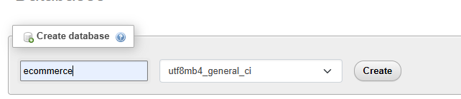
I created a database named ecommerce, which includes the following main tables:
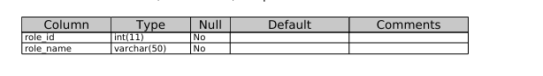
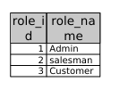
Users Table:
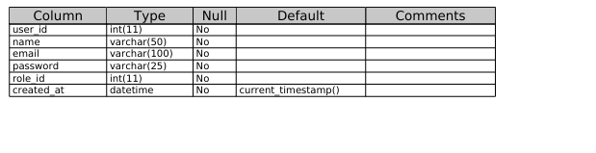
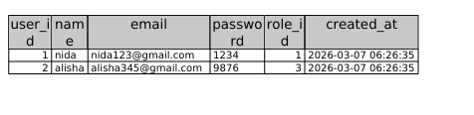
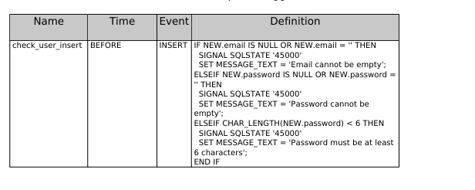
Category Table
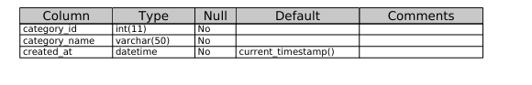
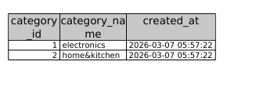

Product Table:
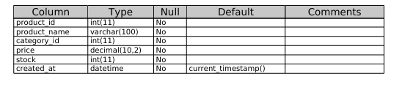
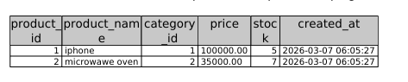
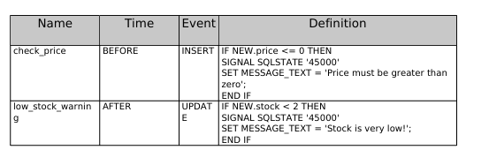
Order Table
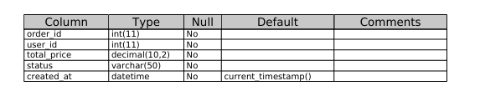
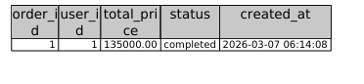
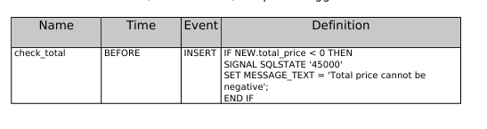
Order_Item Table:

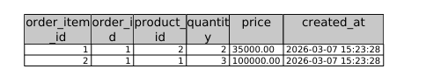
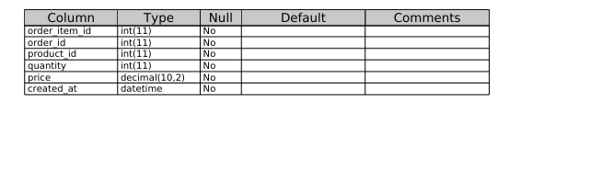
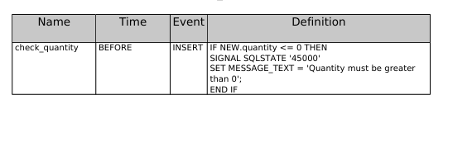
3. Foreign Key Relationships
While designing the database, I created the following relationships:
User.role_id → Role.role_id
(Each user is assigned a role)
Product.category_id → Category.category_id
(Each product belongs to a category)
Orders.user_id → User.user_id
(A user can place multiple orders)
Order_Item.order_id → Orders.order_id
(One order can contain multiple items)
Order_Item.product_id → Product.product_id
(Each item refers to a product)
4.ER diagram:
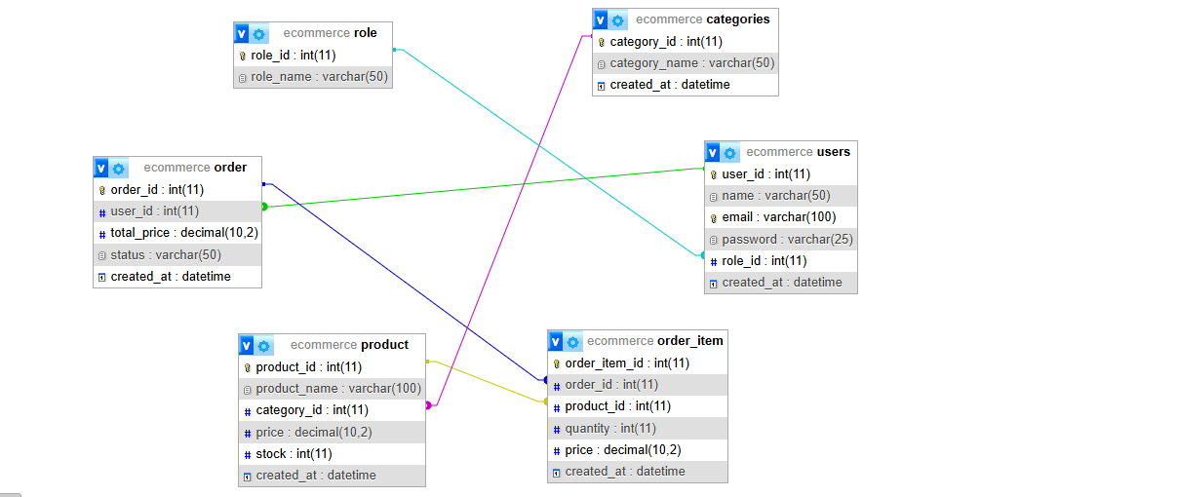
5. Relationship Understanding:
From this design, I understood that:
A user can place multiple orders
Each order can contain multiple products
Products are organized into categories
Roles help manage different types of users
Order_Item acts as a link between orders and products

6. Conclusion:
Overall, this project helped me understand how relational databases work in real-world applications like e-commerce systems. By properly using primary and foreign keys, I was able to connect all tables and maintain data integrity throughout the database design.

